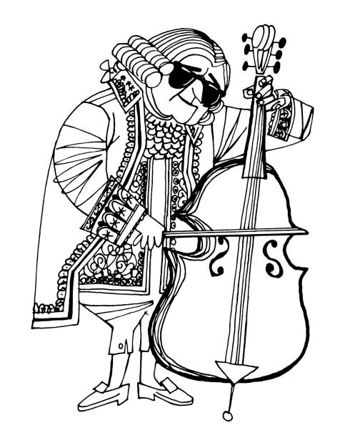
SACHEM NORTH STRING ENSEMBLE
Sachem North
Dear Members and Parents:
The annual trip for the String Ensemble will be to Philadelphia. We’ll go May 15-17. Below is our payment schedule. You will notice that the last payment is still “to be determined” as I cannot let you know the total cost of the trip until everything is set. I will let you know the amount due on March 3 as soon as I know. Please contact me immediately if you have any concerns about this schedule. Payments need to be made on time because I have to make payments on time to the vendors we will be using. Please do not delay as this may negatively affect the entire group. We will discuss fundraising as a group and I hope that you can join us in thinking of ways to raise money. Please send in a cash or a check made payable to SACHEM HIGH SCHOOL NORTH. Early payments are gladly accepted!
September 10 - $50 due (and Thank You!)
October 15 - $100 due
November 12 - $150 due
December 10 - $150 due
January 14 - $100
February 4 - $150
March 3 – TBD if anything is still due
Keep one copy for yourself and return one to me.
Student Name Printed: __________________________________________________

Parent Signature: __________________________________________________________________
Dorie M. Downs - director

