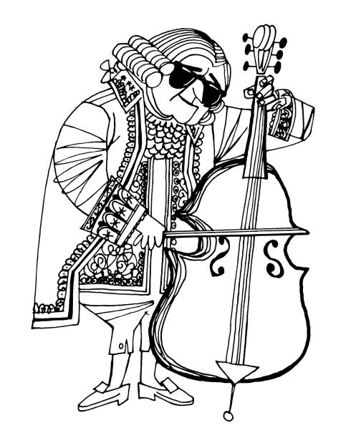
SACHEM NORTH STRING ENSEMBLE
Schedule 2019 – 2020
subject to change
Sachem North
Sept 10 | 5:30 – 7:00 | $50 trip payment due – Officers meet at 5:10
Sept 17 | 5:30 – 7:00 | Seating Auditions
Sept 24 | 5:30 – 7:00
Oct 15 | 5:30 – 7:00 | $100 trip payment due (total $150)
Oct 22 | 5:30 – 7:00 | Officers meet at 5:10
Oct 29 | 5:30 – 7:00
Nov 12 | 5:30 – 7:00 | $150 trip payment due (total $300)
Nov 19 | 5:30 – 7:00
Nov 26 | 5:30 – 7:00 | Officers meet at 5:10
Dec 3 | 6:30 – 7:30 | 7:00 performance at Atria Hertlin House on Portion Road
Dec 10 | No rehearsal | $150 trip payment due (total $450)
Dec 17 | 5:30 – 7:00
Jan 7 | 5:30 – 7:00
Jan 14 | 5:30 – 7:00 | Officers meet at 5:10 - $100 trip payment due (total $550)
Jan 21 | 5:30 – 7:00
Jan 30 | 6:45 call | SCHOOL CONCERT
Feb 4 | 5:30 – 7:00 | Officers meet at 5:10 - $150 trip payment due (total $700)
Feb 11 | 5:30 – 7:00
Feb 25 | 5:30 – 7:00
Mar 3 | 5:30 – 7:00 | $TBD trip payment due – this is the final payment
Mar 10 | 5:30 – 7:00
Mar 24 | 5:30 – 7:00 | Officers meet at 5:10
Mar 31 | 5:30 – 7:00
Ap 14 | 5:30 – 7:00 | Trip packet out
Ap 21 | 5:30 – 7:00 | Officers meet at 5:10
Ap 28 | 5:30 – 7:00 | Trip permission slip & medical form due back
May 12 | 5:30 – 7:00
May 15 – 17 | TIMES TBD | Trip
May 26 | 6:45 call | SCHOOL CONCERT
TBD | 5:30 – 7:00 | End of the year party thrown by the 9th – 11th graders
As you know, this is an auditioned honors ensemlbe. Your attendance is mandatory – not subject to the whims of concert tickets; extra homework; or sleep. Although I appreciate all of those things, we have work to do; performances to put on; and music to make. You are expected to be at every rehearsal. If you cannot keep that commitment than you will be dismissed from the ensemble.
Once you make a trip payment I make a payment to the vendors we are using. If you change your mind about SNSE or you are removed from the ensemble (this has never, ever happened) I will do the best I can to retrieve your trip money.
That said – TALK TO ME. If you have an issue talk to me before you face consequences you’re not ready to face.
Put these dates on your calendar (and a family calendar now if you need). Work out rides in advance if you need to.
No excuses – only excellent music.

